**News**

<https://www.uniladtech.com/apple/ios-18-math-notes-feature-363204-20240917>

Summary of above: The notes app is getting a bunch of new features

Purpose: Potential competition

<https://www.proquest.com/abicomplete/docview/3126904896/2B4B8EB0E3DC4658PQ/1?accountid=14749&sourcetype=Blogs,%20Podcasts,%20&%20Websites>

Summary of above: Cool article detailing all the ways people are using the notes app

Purpose: Potential competition

***Found on the USC Library Resources***

<https://global-factiva-com.libproxy2.usc.edu/ha/default.aspx?page_driver=searchBuilder_Search#./!?&_suid=174173604535902767559017185781>

Summary of above: Apple/ChatGPT deal

Purpose: Potential competition:

***Found on the USC Library Resources***

<https://global-factiva-com.libproxy2.usc.edu/ha/default.aspx?page_driver=searchBuilder_Search#./!?&_suid=174173619432804474227110869442>

Summary: AR glasses predictions for 2025. Meta in the lead. Snapchat close behind.

Purpose: AR industry information

***Found on the USC Library Resources***

<https://global-factiva-com.libproxy2.usc.edu/ha/default.aspx?page_driver=searchBuilder_Search#./!?&_suid=174173619432804474227110869442>

Summary: Meta is making a bunch of other AR tech right now too besides Orion.

Purpose: AR industry information

***Found on the USC Library Resources***

<https://global-factiva-com.libproxy2.usc.edu/ha/default.aspx?page_driver=searchBuilder_Search#./!?&_suid=1741736486424042860624811889725>

Summary: Offers support about our theories about the aging population and using AI to solve their issues.

Purpose: Tech in the aging population industry.

***Found on the USC Library Resources***

<https://www.aboutamazon.com/news/devices/new-alexa-generative-artificial-intelligence>

Summary: Alexa is getting a big upgrade this year with lots of agentic capabilities. Much closer to our type of product.

Purpose: Potential competition

<https://orbis-r1-bvdinfo-com.libproxy2.usc.edu/version-20241204-7-0/Orbis/1/Companies/report/Index?backLabel=Back%20to%20Key%20information&format=_standard&BookSection=PATENTPORTFOLIO&seq=0&sl=1741737355261>

Summary: Meta’s patent activity found on Orbis

Purpose: Gives an idea of what meta cares about. Mostly AR features - not use cases.

<https://www.alzheimers.org.uk/research/our-research/dementia-innovation/longitude-prize>

Summary: Has some direct competitors listed for us

Purpose: Source of competitors

<https://www.carecity.org/about/>

Summary: The Dorothy team is working on an AR yellow brick road map for people with dementia.

Purpose: Info on competitors

<https://www.ku.ac.ae/khalifa-university-team-develop-smart-glasses-for-dementia-reach-next-stage-in-longitude-prize-on-dementia>

Summary: Direct competitor. Made their own glasses. Research based.

Purpose: Info on competitors

<https://amicusbrain.com/ai-advisor-dementia-solutions/>

Summary: Future competitor

Purpose: Info on competitors

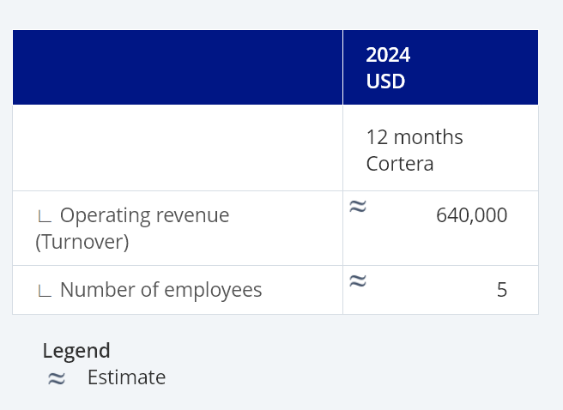Financial data for amicus

<https://www.gartner.com/document/5849947>?

Summary: Spatial computing industry insights

**Found with USC library resources**

<https://www.gartner.com/document/4214999>?

Summary: Info about ChatGPT uses in healthcare

Point: People are thinking about this

**Found with USC library resources**

[**https://my-ibisworld-com.libproxy2.usc.edu/us/en/company-benchmarking/10474/company-overview**](https://my-ibisworld-com.libproxy2.usc.edu/us/en/company-benchmarking/10474/company-overview)

**Meta company overview / statistics**

[**https://my-ibisworld-com.libproxy2.usc.edu/us/en/company-benchmarking/10474/us-od6181**](https://my-ibisworld-com.libproxy2.usc.edu/us/en/company-benchmarking/10474/us-od6181)

**Meta SWOT Analysis**